**Korvage Development Docs**

1. **Create a Child Theme**
   1. **Create Folder add name Korvage**
   2. **Add style.css and function.php file int**
2. **Name to Child Theme and add data in theme**
   1. **Open style.css and add detail, Just like this  
      /\*\***
   2. **\* Theme Name: Korvage**
   3. **\* Author: Nakul Suri**
   4. **\* Template: kadence**
   5. **\* Text Domain: korvage**
   6. **\* Description: korvage Theme is a lightweight yet full featured WordPress theme for creating beautiful fast loading and accessible websites, easier than ever. It features an easy to use drag and drop header and footer builder to build any type of header in minutes. It features a full library of gorgeous starter templates that are easy to modify with our intelligent global font and color controls. With extensive integration with the most popular 3rd party plugins, you can quickly build impressive ecommerce websites, course websites, business websites, and more.**
   7. **\* Version: 1.0**
   8. **\* Tags: software-development, web-development, app-development, digital-marketing, web-design,**
   9. **\*/**

**b . Open functions.php and create function   
 function korvage_style(){  
 wp_enqueue_style('child-style', get_stylesheet_uri());**

**}**

1. Add Any Bootstrap template I choose agency bootstrap template
2. Add all files in your child theme and create folder template in it add all the pages in it
3. Create header.php and footer.php and add header and footer code in it from your template and remove header footer from all template add this in place of header  
   <?php
4. **
5. * Template Name: Home Page */
6. get_header();
7. ?>/

And this in place of footer   
<?php get_footer(); ?>

Name the template above get_header() * Template Name: Home Page */

**6. Now go in header.php and remove all the code above header tag and add this  
<?php**

**/\*\***

**\* Header file for the Home Page templates.**

**\***

**\* @link https://developer.wordpress.org/themes/basics/template-files/#template-partials**

**\***

**\* @package WordPress**

**\* @subpackage Korvage**

**\* @since Korvage**

**\*/**

**wp_head()**

**?>**

**7. Go to footer.php and remove all the code of calling script and add this at this place <?php wp_footer(); ?>**

**That code help you to call scripts from functions.php**

**8. Add Script and style in functions.php**

**wp_enqueue_style('Responsive-Css', get_stylesheet_directory_uri() . '/asset/css/responsive.css');**

**wp_enqueue_style('google-fonts', 'https://fonts.googleapis.com/css2?family=Outfit:wght@100..900&display=swap', array(), null);**

**// Enqueue child theme scripts**

**wp_enqueue_script('popper', get_stylesheet_directory_uri() . '/asset/js/popper.min.js', array('jquery'), '1.0.0', true);**

**wp_enqueue_script('bootstrap', get_stylesheet_directory_uri() . '/asset/js/bootstrap.min.js', array('jquery'), '1.0.0', true);**

**Use wp_enqueue_script to call js scripts and wp_enqueue_style to call stylesheet**

**Use this get_stylesheet_directory_uri()**

**Instead of using theme path**

**9. Now basic setup is completed, Install ACF** [**https://wordpress.org/plugins/advanced-custom-fields/**](https://wordpress.org/plugins/advanced-custom-fields/)

1. **To add new fields in pages,taxonomies and post type we use field group**
   1. **First name field group**
   2. **Add Field name**
   3. **Provide location where you want to show that field**
2. **To add new post type**
   1. **Add post type name**
   2. **Choose fields and slug you want to show**
3. **To add Taxonomies**
   1. **Add Taxonomies name**
   2. **Choose post type in which you want to add taxonomies**

**10. As I already added All ACF fields and Kindly import ACF file in tools**

**ADD Contact Form**

1. **Create Contact form** [**https://wordpress.org/plugins/contact-form-7/**](https://wordpress.org/plugins/contact-form-7/)
2. **Copy shortcode and go to the template in which we need to add the form and the code like this <?php echo do_shortcode('[contact-form-7 id="9b8714e" title="Contact form 1"]');?>**

**to call the form**

1. **Now add another plugin** [**https://wordpress.org/plugins/country-phone-field-contact-form-7/**](https://wordpress.org/plugins/country-phone-field-contact-form-7/)
2. **Add phone field and country condition**

**Insert Data**

1. **Import data from demo data folder, import xml file** **tool > import**
2. **Now Install plugin** [**https://wordpress.org/plugins/widget-importer-exporter/**](https://wordpress.org/plugins/widget-importer-exporter/)
3. **There is a WIE file in demo data import it from tool>widget importer and exporter**

**Change and Update Data**

1. **For boxes of choose us , technology boxes and sliders boxes that all you will find out in services post type you can find it using their category name which similar to their type**
2. **For brand, technologies we work and industries all images you will find in industries post type and you can find it using their name in the category**
3. **For Faq there is a faq post type which is categories by page name**
4. **For testimonial you will get a testimonial post type**
5. **For remaining data just go to the page and edit the content according to their section**

**Add New template**

1. **Create a page in php and provide them a name as explained above in point 5**
2. **After creating a page make it dynamic using ACF**
3. **Create a new field type for a new template add fields like title and description and all  
   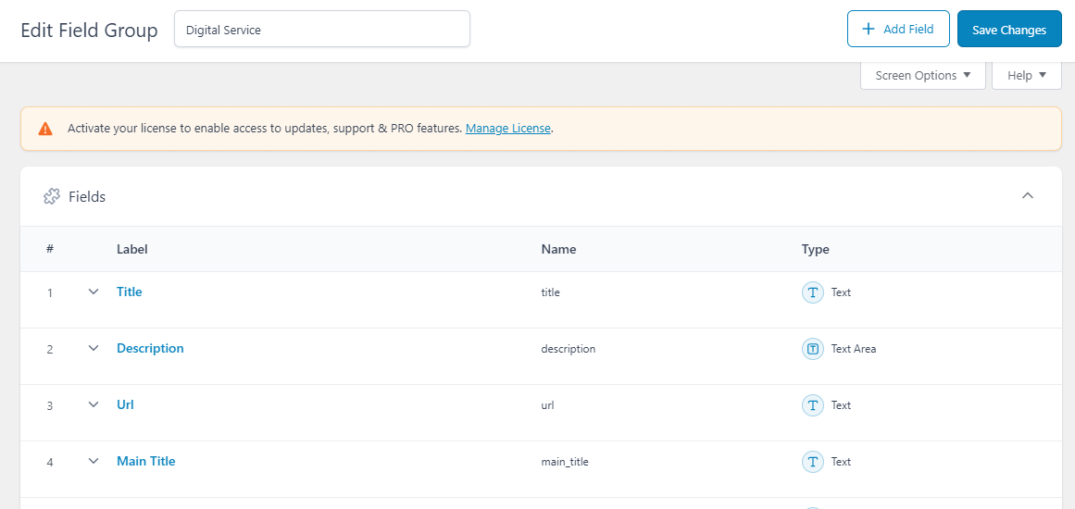**
4. **Provide their location to that new template name  
   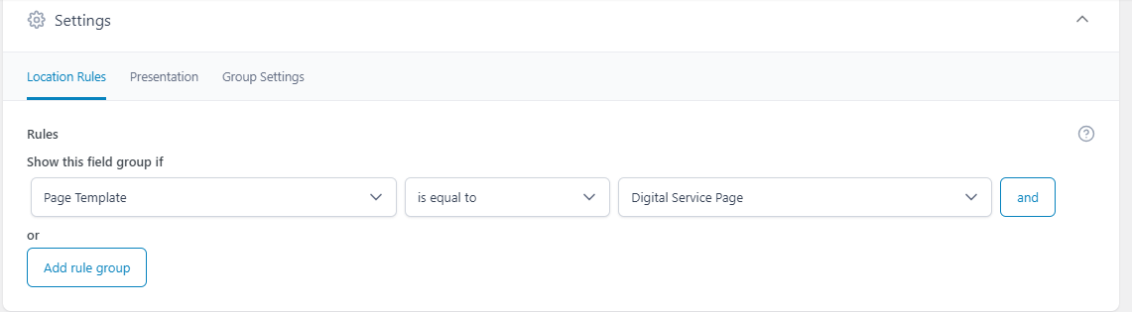**
5. **Then create new page and in that page select your template in right corner after select the field you created will be shown like this  
   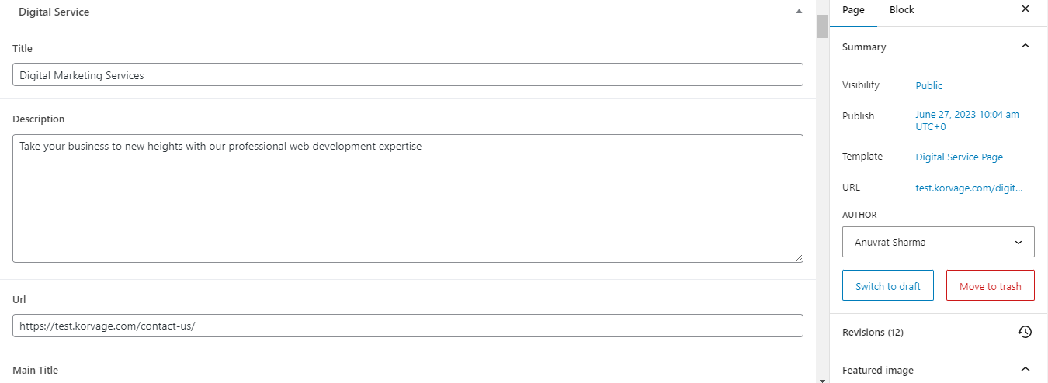**
6. **Add the content Now let me tell how to call them in the code** 
   1. **If you are calling text and text area you can call it like this  
       <?php echo esc_html(get_field('your-field-name')); ?>**
   2. **If it’s an image or url you can call it like this   
      Note: While selecting image always use format as image url  
      <?php echo esc_url(get_field('your-field-name')); ?>**
   3. **If your using group use this code as reference group (‘group title)[Field]’  
      <p><?php echo esc_html(get_field('process')['title']); ?></p>**

**<div style="color:black"><?php echo esc_html(get_field('process')['description']); ?></div>**

1. **Now how to call a service  
   A. If you have taxonomy(relation) you have to call it like that  
   <?php**

**// Query to fetch posts from Industries custom post type**

**$args = array(**

**'post_type' => 'industries',**

**'posts_per_page' => -1,**

**'order' => 'ASC',**

**'tax_query' => array(**

**array(**

**'taxonomy' => 'industries', // Taxonomy name**

**'field' => 'name',**

**'terms' => 'Global Brands', // Term name**

**)**

**)**

**);**

**$industries_query = new WP_Query($args);**

**if ($industries_query->have_posts()) :**

**while ($industries_query->have_posts()) : $industries_query->the_post();**

**?>**

**Don't forgot to end  
<?php**

**endwhile;**

**wp_reset_postdata(); // Reset the query**

**else :**

**// If no posts found**

**echo '<p>No industries found.</p>';**

**endif;**

**?>**

**Like this  
   
B. If you are not using taxonomy   
 <?php**

**// Query testimonial posts**

**$args = array(**

**'post_type' => 'testimonials',**

**'posts_per_page' => -1, // Show all testimonials**

**'order' => 'ASC',**

**);**

**$testimonials = new WP_Query($args);**

**if ($testimonials->have_posts()) :**

**$count = 0;**

**while ($testimonials->have_posts()) :**

**$testimonials->the_post();**

**?>**

**C. Little info for calling title of the page use   
the_title()  
For calling description of page use  
the_content()  
For calling featured image use  
<?php**

**if (has_post_thumbnail()) {**

**the_post_thumbnail('medium', ['class' => 'mb-3 px-4']);**

**}**

**?>**